**Ratio**nal Numbers

Any square root of a perfect square is rational. The square root of any non-perfect square is irrational

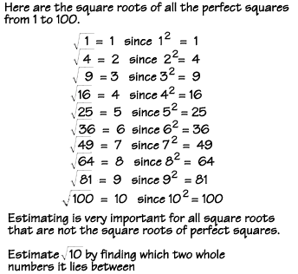

**Irratio**nal Numbers are the opposite of rational

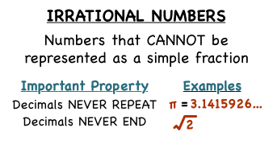

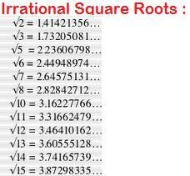

Multiplying Binomials

Using Double Distribution

****Stay Organized****

(DRAW THE ARROWS)

(FOIL)

First, Outside, Inside, Last

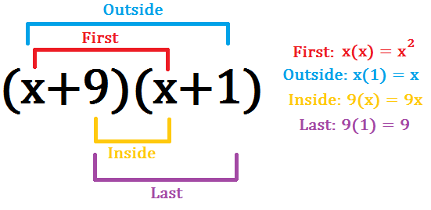

**Combining Like Terms**

(Add and subtract the things we can)

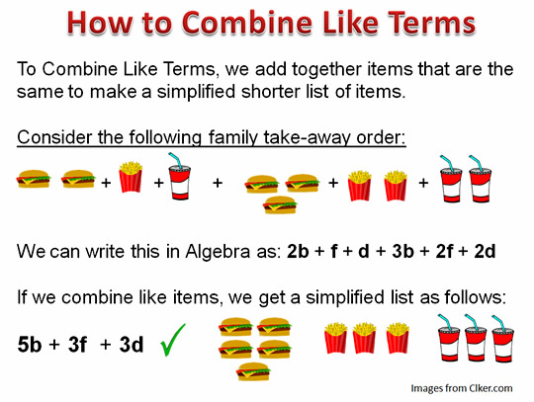They have to have the **same base** and the **same exponent** to be able to be combined

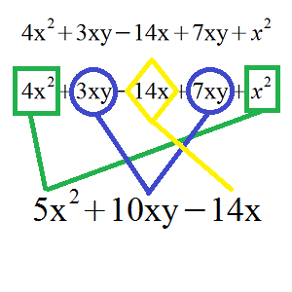

Simplifying radicals in general

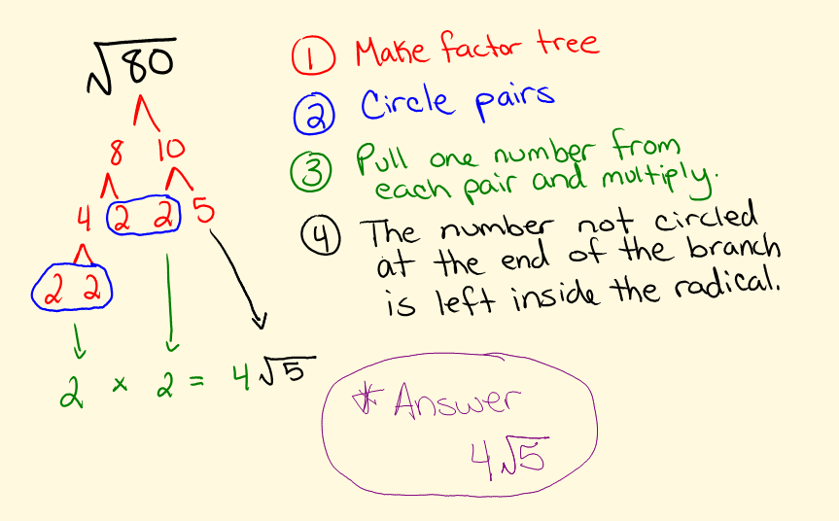

**Simplifying radicals** involving negative numbers

We can really work with negative radicands, it’s like it’s against the rules, look at the wrong answer below, then the correct one

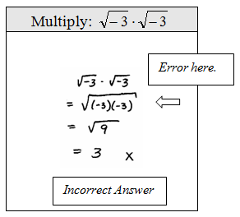

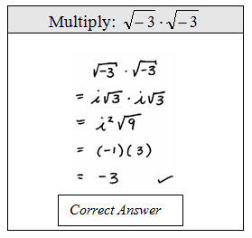

**Simplifying radicals** involving negative numbers

**Take out i !!!!!!!!**

it becomes positive

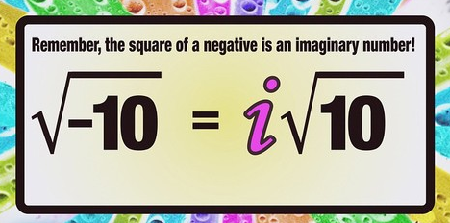

**Simplifying i (to a big number)**

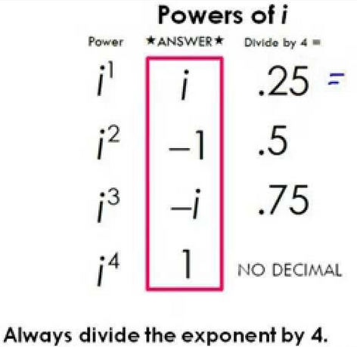

E.g., i25  🡪 25 /4 = 6**.25 🡪** i25 = i

**Zero exponents** in general

**ANYTHING TO THE**

**POWER OF ZERO EQUALS 1**

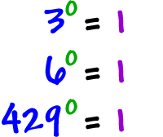

**EVEN FRACTIONS!!!!!** The denominator can never be zero, in general, for ANY fraction, ever, ever, ever, that is called **undefined**. We literally can’t define it!!! So that scenario doesn’t exist to us as mathematicians.

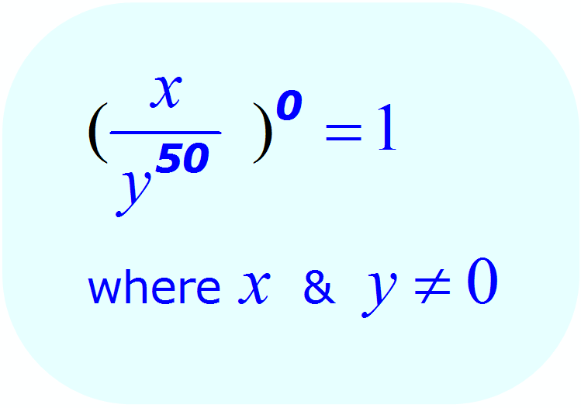

**Negative exponents** in general

**Flip it 🡪 exponent becomes positive**

(Math Language: Find the positive reciprocal)

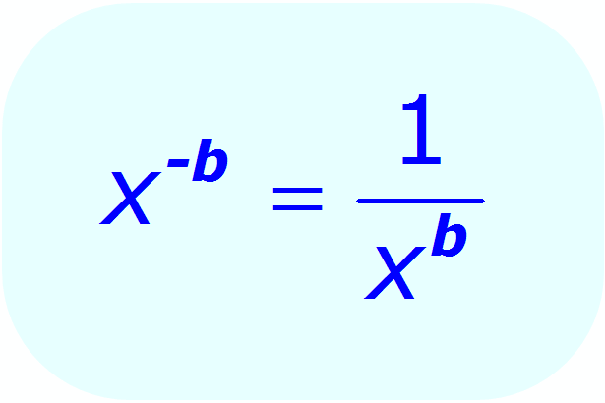

Negative exponents example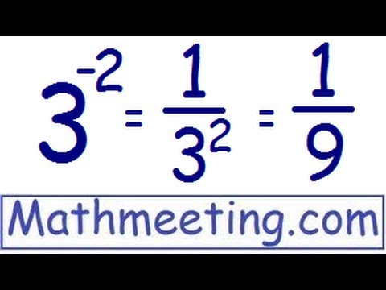

**Fractional Exponents** in general

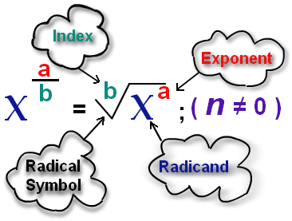

Fractional Exponents example

**\*\*NOTICE** The exponent of the 8 under the radical symbol is 1,** that is something we assume and don’t always write out. We say it is **“implied”**

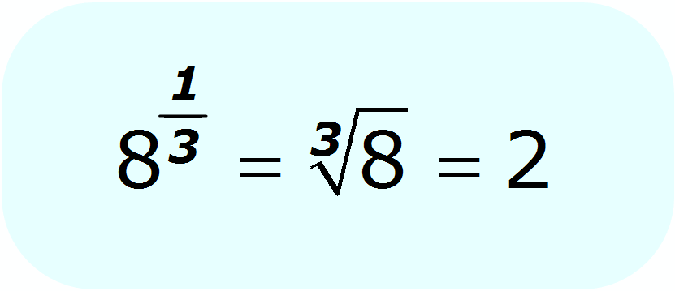

** VERY IMPORTANT****COMMON MISTAKE FOR **US**

**(We are looking at your work ☺)**

LOOK carefully at **EXAMPLE 2-2** and how we write equivalent expressions using exponents

\*\***Exponents are GLUED to the base!**

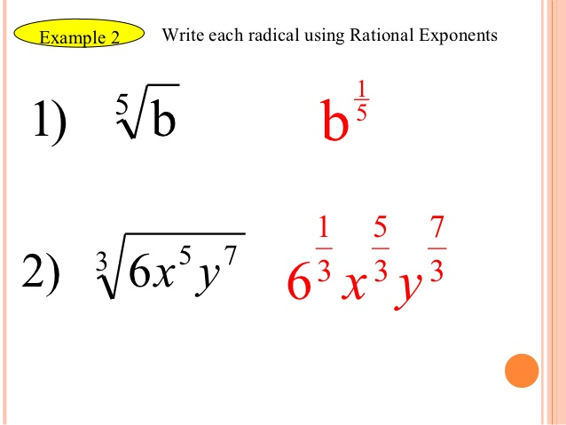

**- 42** = -16 These are different (**- 4)2** = 16

(Both True)

**Factoring Trinomials using AC (3 Terms) pg1**

**How do we factor 8X2 – 10X +3**

**This: Is a quadratic expression with a leading coefficient other then one*****see the 8\*\*\*\***

1. **Identify the Coefficients A, B, and C**

[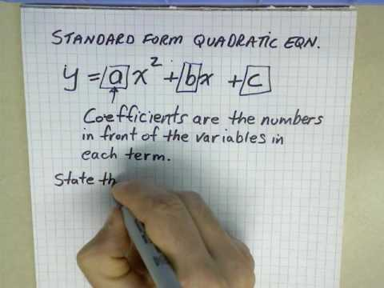](https://www.google.com/url?sa=i&rct=j&q=&esrc=s&source=images&cd=&ved=0ahUKEwiR7O3qiI3XAhXpslQKHZ4tB1cQjRwIBw&url=https://www.youtube.com/watch?v=5Me7alplpbU&psig=AOvVaw1IlRMz6HQ3cwMmDZBuFyKD&ust=1509065333154131)

**In this expression: 8X2 – 10X +3**

**A = 8**

**B = -10**

**C = 3**

1. **Multiply: Find A times C.**

**A = 8 B = -10 C = 3**

**So……………**

**AC = 8 x 3**

**AC = 24**

**Factoring Trinomials using AC (3 Terms) pg2**

1. **List factor pairs for AC**

**1 x 24**

**2 x 12**

**3 x 8**

**4 x 6**

**-1 x -24**

**-2 x -12**

**-3 x -8**

**-4 x -6**

1. **Find the factor pair with a SUM of B and rewrite.**

**A = 8 B = -10 (we need a sum of -10) C = 3**

**The pair from our last step, - 4 - 6 = -10**

**Rewrite the expression** with the pair you identified as the **two middles terms,** the “B” terms

**Original: 8X2 – 10X +3**

**New: 8X2 – 4X – 6X +3**

**\*\*\*Notice the middles terms are -4X and -6X\*\*\***

**Don’t forget the X**

**Factoring Trinomials using AC (3 Terms) pg3**

1. **Do the Split we use to factor 4 term expressions, look at one side at a time.**

**8X2 – 4X – 6X +3**

**\*\*\*Keep in mind we are looking for smileys\*\*\***

**4X (2X-1) 3(-2x+1) 🡪 No smileys ☹**

**☹ Different ☹**

**\*\*\*Your first try might not have a smileys, look for the matching pair\*\*\***

**4X (2X-1) -3(2x-1) 🡪This works ☺**

**☺ ☺**

1. **Rewrite the expression using what you know about equivalence and smiles ☺**

**4X (2X-1) -3(2x-1)**

**☺ ☺**

**Turns into…**

**(2X-1)(4x-3)**

**☺**

**Factoring Trinomials using AC (3 Terms)**

**THE SHORT VERSION**

**How do we factor 8X2 – 10X +3?**

Standard Form:**🡪 ax2 + bx + c [](https://www.google.com/url?sa=i&rct=j&q=&esrc=s&source=images&cd=&ved=0ahUKEwjfh7LFno3XAhVF1CYKHdXFCR0QjRwIBw&url=http://hddfhm.com/clip-art/mit-clipart.html&psig=AOvVaw2tTFI24ws9c8_C4xKJ6bo_&ust=1509071101141621)**

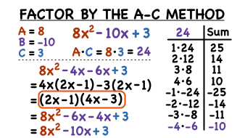

|  |
| --- |
| **\*\*\*The answer is circled: (2x-1)(4x-3),**  **The last 2 lines are for a check of the work\*\*\***  Use your eyes to see where the numbers are coming from  This space is for **your own notes, please use it ☺** |

**Factoring Binomials (2 Terms)**

Look out for These! We proved them, now **Know Them**

A-B 🡪 = -1

B-A

Examples to look at, it always works!

5-18 🡪 = -1

18-5

300-50 🡪 = -1

50-300

X-18 🡪 = -1

18-X

|  |
| --- |
| This space is for **your own notes, please use it ☺** |

**Factoring Binomials (2 Terms) using DOTS DOTS = (Difference of two squares)**

Look out for the identifiers below! The title helps ☺

**1) MINUS** in the **MIDDLE** (difference)

**2) TWO** terms that are perfect **SQUARES** (of two squares)

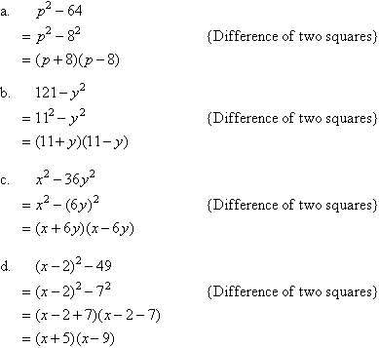

|  |
| --- |
| Look at this set of examples to see the pattern…..What do you notice happening? 🡪 Do that…..This space is for **your own notes, please use it ☺** |

**Probability** Conditional-for a given event

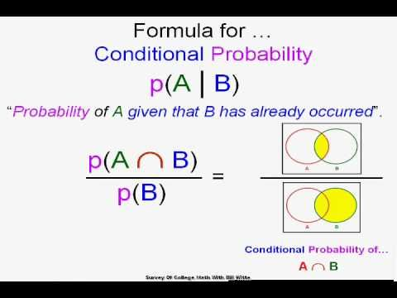

For **GIVEN** statements, remember the given condition is **the denominator.**

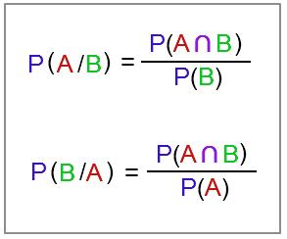

**Probability** Conditional-The relationship of AND and GIVEN

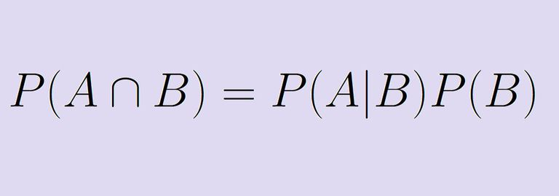

We can write this more than 1 way and get the same answer

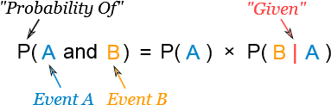

**Probability** Tree Diagrams

